Lab 6 (goovy command)

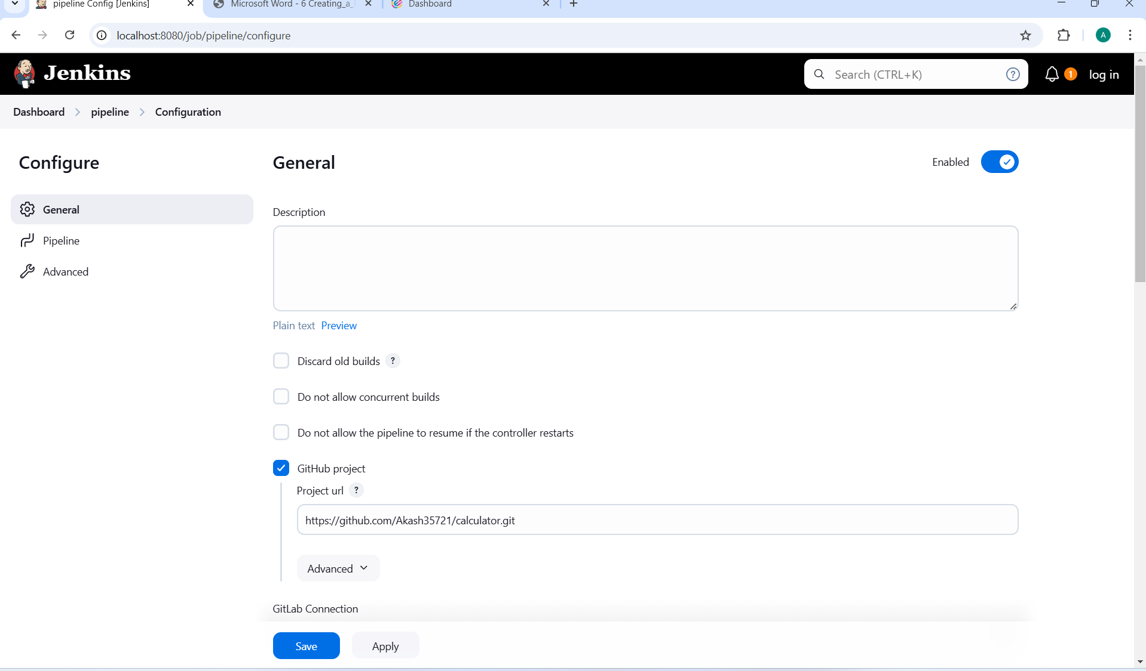

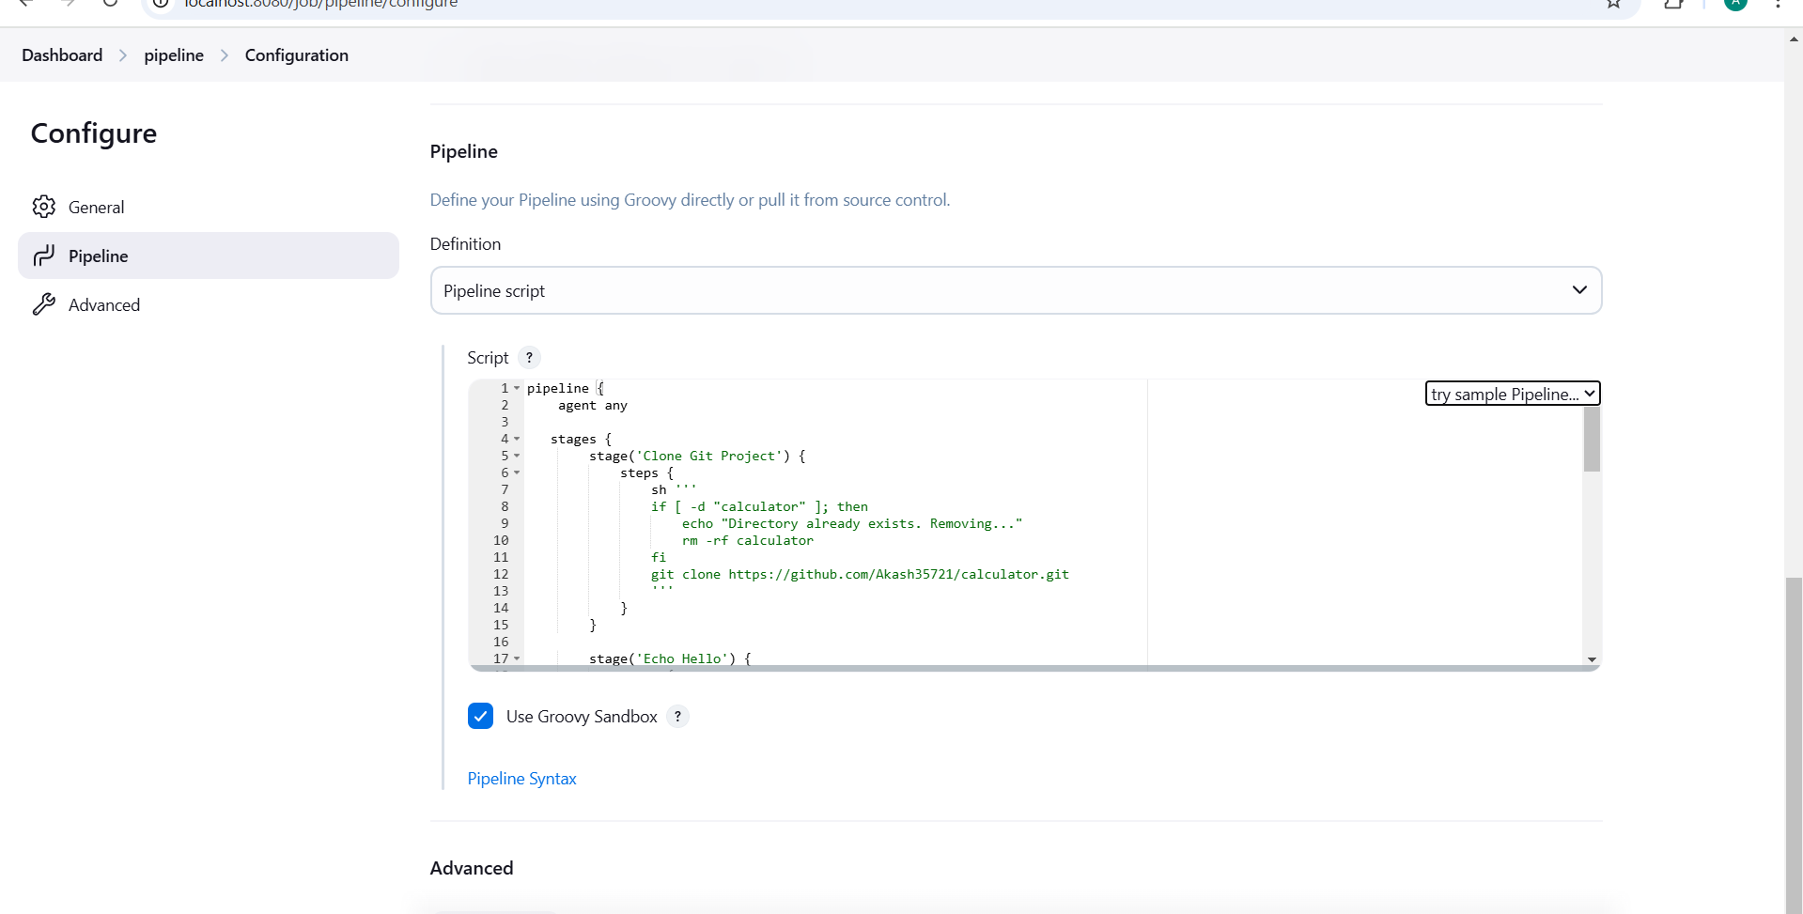

**Write code**

pipeline {

agent any

stages {

stage('Clone Git Project') {

steps {

sh '''

if [ -d "calculator" ]; then

echo "Directory already exists. Removing..."

rm -rf calculator

fi

git clone https://github.com/Akash35721/calculator.git

'''

}

}

stage('Echo Hello') {

steps {

sh 'echo "Hello"'

}

}

stage('Take User Input') {

steps {

script {

def userInput = input message: 'Enter your name:', parameters: [string(name: 'USERNAME', defaultValue: 'User')]

echo "Hello, ${userInput}!"

}

}

}

stage('Determine Current Directory') {

steps {

sh 'pwd'

}

}

stage('Change Directory to Home') {

steps {

sh 'cd ~ && pwd'

}

}

stage('Compile and Run Java File') {

steps {

sh '''

cd calculator

javac Calculator.java

java Calculator

'''

}

}

stage('Delete a Directory') {

steps {

sh 'rm -rf calculator }

}}

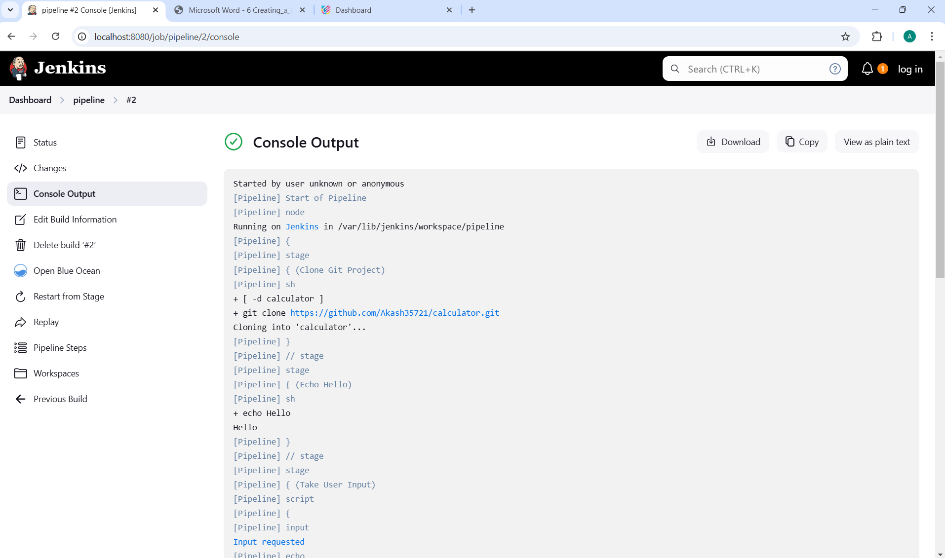

**Now next project**

Make a Java program for addition and subtraction where you have to pass three command-line arguments 1. Task (addition or subtraction )

2. First integer value

3. Second integer value

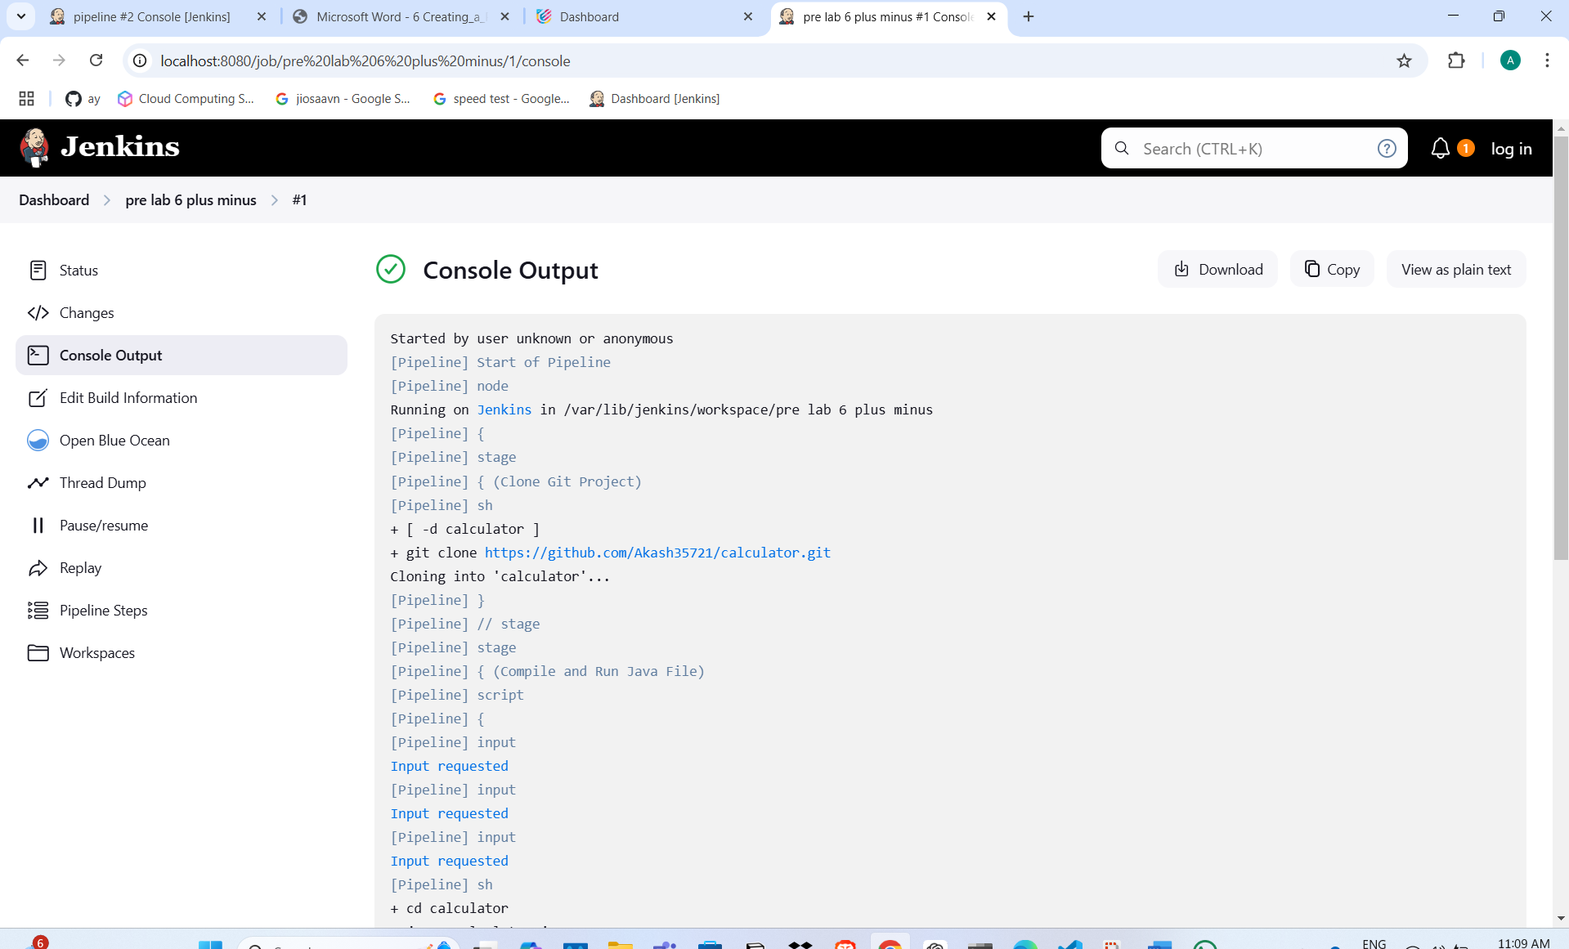

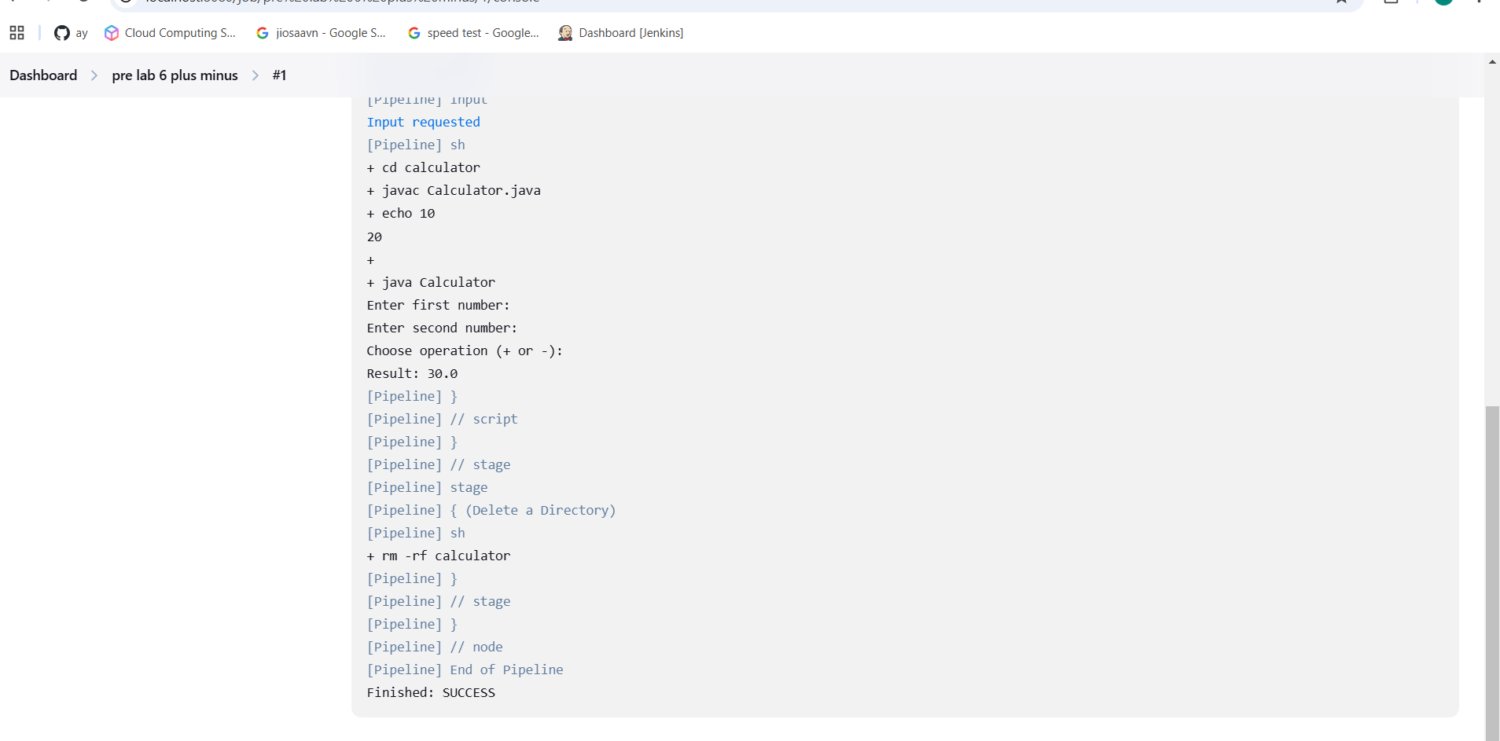

**Using guvi command**

pipeline {

agent any

stages {

stage('Clone Git Project to Home Directory') {

steps {

sh '''

cd ~

if [ -d "calculator" ]; then

echo "Directory already exists in home. Removing..."

rm -rf calculator

fi

git clone https://github.com/Akash35721/calculator.git

'''

}

}

stage('Echo Hello') {

steps {

sh 'echo "Hello"'

}

}

stage('Take User Input') {

steps {

script {

// Prompt for first number

def num1 = input message: 'Enter first number:', parameters: [string(name: 'NUM1', defaultValue: '0')]

// Prompt for second number

def num2 = input message: 'Enter second number:', parameters: [string(name: 'NUM2', defaultValue: '0')]

// Prompt for operation (+ or -)

def operation = input message: 'Choose operation (+ or -):', parameters: [string(name: 'OPERATION', defaultValue: '+')]

// Store values in environment variables to use later in shell script

env.NUM1 = num1

env.NUM2 = num2

env.OPERATION = operation

}

}

}

stage('Determine Current Directory (Home)') {

steps {

// Ensure we're in the home directory

sh 'cd ~ && pwd'

}

}

stage('Compile and Run Java File') {

steps {

sh '''

cd ~/calculator

javac Calculator.java

# Pass user input to the Java program via standard input.

# The Java program (Calculator.java) should expect three lines:

# first number, second number, and the operation.

echo "${NUM1}\n${NUM2}\n${OPERATION}" | java Calculator

'''

}

}

stage('Delete the Calculator Directory') {

steps {

sh 'rm -rf ~/calculator'

}

}

}

}

